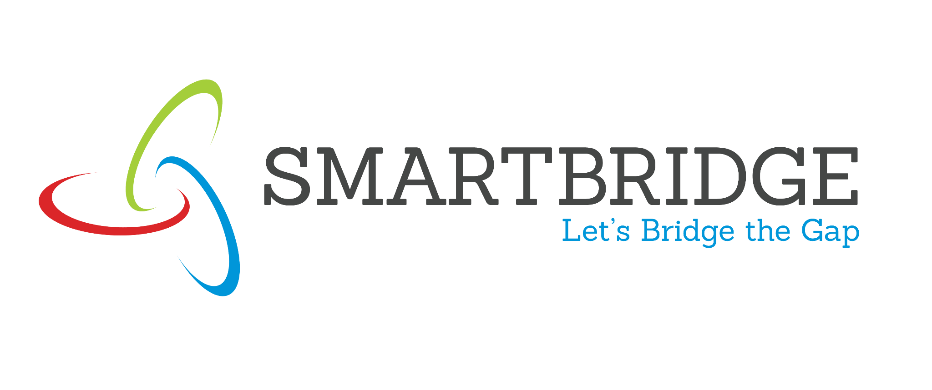 | 
Project Initialization and Planning Phase
Date July 7, 2026
Team ID 12344 | PNT2022TMID124356
Project Title | SmartLender - Applicant Credibility Prediction for Loan Approval
Maximum Marks | 5 Marks

Opticrop - Proposed Solution Project Proposal (Proposed Solution) report
The proposal report aims to transform loan approval using machine learning, boosting efficiency and accuracy. It tackles system inefficiencies, promising better operations, reduced risks, and happier customers. Key features include a machine learning-based credit model and real-time
2. Yield Forecaster - RF regressor predicts final yield in t/ha decision-making.
3. Soil Diagnoser - K-Means clustering into 5 soil health clusters
4. NPK Prescriber - deficit-based Urea / SSP / MOP amendment guide Project Overview
5. Analytics Dashboard- acc Objective | racy charts, confusion matrix, feature importance  The primary objective is to revolutionize the loan approval process by implementing advanced machine learning techniques, ensuring faster and more accurate assessments.
Scope | The project comprehensively assesses and enhances the loan approval process, incorporating machine learning for a more robust and  efficient system.
Problem Statement
Description | Addressing inaccuracies and inefficiencies in the current loan approval system adversely affects operational efficiency and customer satisfaction.
Impact | Solving these issues will result in improved operational efficiency, reduced risks, and an overall enhancement in the lending process, contributing to customer satisfaction and organizational success.
Proposed Solution
Approach | Employing machine learning techniques to analyze and predict creditworthiness, creating a dynamic and adaptable loan approval system.
Key Features | - Implementation of a machine learning-based credit assessment model.

 | 

-​Real-time decision-making for quicker loan approvals.
-​Continuous learning to adapt to evolving financial landscapes.
Resource Requirements
Resource Type | Description | Specification/Allocation
Hardware
Computing Resources | CPU/GPU specifications, number of cores | T4 GPU
Memory | RAM specifications | 8 GB
Storage | Disk space for data, models, and logs | 1 TB SSD
Software
Frameworks | Python frameworks | Flask
Libraries | Additional libraries | scikit-learn, pandas, numpy, matplotlib, seaborn
Development Environment | IDE | Jupyter Notebook, pycharm
Data
Data | Source, size, format | Kaggle dataset, 614, csv UCI dataset, 690, csv

